**SMART IRRIGATION SYSTEM USING IOT**

A COURSE PROJECT REPORT

By

**N. SRAVAN KUMAR(RA2111047010189)**

**P. VENU GOPALA REDDY (RA2111047010188)**

**C. GOKUL KRISHNA REDDY(RA2111047010190)**

**B. PHANINDRA BABU(RA2111047010193)**

**G.M. PRAVEEN KUMAR(RA2111047010191)**

Under the guidance of   
**Dr. K. VIJAY KUMAR**

**Assistant Professor, Department of Computational Intelligence**

*In partial fulfilment for the Course* of

18AIS203J - COMPUTER NETWORKS AND COMMUNICATIONS

in CINTEL



**FACULTY OF ENGINEERING AND TECHNOLOGY SRM INSTITUTE OF SCIENCE AND TECHNOLOGY**

**Kattankulathur, Chenpalpattu District**

APR 2023

**SRM INSTITUTE OF SCIENCE AND TECHNOLOGY**

**(Under Section 3 of UGC Act, 1956)**

**BONAFIDE CERTIFICATE**

Certified that this mini project report “**SMART IRRIGATION SYSTEM USING IOT** “is the bonafide work of **N. SRAVAN KUMAR(RA2111047010189) P. VENU GOPALA REDDY (RA2111047010188) C. GOKUL KRISHNA REDDY(RA2111047010190) B. PHANINDRA BABU(RA2111047010193) G.M. PRAVEEN KUMAR(RA2111047010191)** who carried out the project work under my supervision.

# 

# SIGNATURE

Dr. K. Vijaya Kumar,

**Assistant Professor**

# CINTEL

SRM Institute of Science and Technology,

Kattankulathur.

**TABLE OF CONTENTS**

## CHAPTERS CONTENTS PAGE NO.

* + - 1. **ABSTRACT**
      2. **INTRODUCTION**
      3. **REQUIREMENT ANALYSIS**
      4. **ARCHITECTURE & DESIGN**
      5. **IMPLEMENTATION**
      6. **EXPERIMENT RESULTS & OUTPUT**
      7. **CONCLUSION**
      8. **REFERENCES**

# ACKNOWLEDGEMENT

We express our heartfelt thanks to our honourable **Vice Chancellor Dr.C. MUTHAMIZHCHELVAN**, for being the beacon in all our endeavours.

We would like to express my warmth of gratitude to our **Registrar Dr. S. Ponnusamy,** for his encouragement

We express our profound gratitude to our **Dean (College of Engineering and Technology) Dr. T.V.Gopal,** for bringing out novelty in all executions.

We would like to express my heartfelt thanks to Chairperson, School of Computing **Dr. Revathi Venkataraman,** for imparting confidence to complete my course project

We wish to express my sincere thanks to **Course Audit Professor Dr.B.AMUTHA, Professor, Computing Technologies &** **Course coordinator Dr.K.Vijayakumar** for their constant encouragement and support.

We are highly thankful to our my Course project Faculty **Dr.K.Vijaykumar , AP, CINTEL,** for herassistance, timely suggestion and guidance throughout the duration of this course project.

We extend my gratitude to our **HOD Dr. ANNIE UTHRA, Professor** and my Departmental colleagues for their Support.

Finally, we thank our parents and friends near and dear ones who, directly and indirectly contributed to the successful completion of our project. Above all, I thank the almighty for showering his blessings on me to complete my Course project.

# ABSTRACT

Irrigation system is a method used to supply water to the plants as uniformly as possible. In the Internet of Things (IoT), technology devices or sensors are connected via the internet and can be remotely operated and monitored by the user. the implementation is done by performing the simulation for a smart irrigation system with the help of the Cisco packet tracer simulation This technology can be implemented for developing a smart irrigation system, which consists of devices like a lawn sprinkler, temperature monitor, Humidity monitor, etc., to automate the watering system and remotely monitor the environmental conditions for better growth of the plants. All the devices are connected to the home gateway and can be remotely operated and monitored using a Tablet/PC/Smartphone.

Simulation results show that the smart devices such as a sprinkler system and other essential devices for monitoring environmental conditions are connected to the home portal and can be successfully monitored, which helps the farmers/homeowners to grow and maintain plants with ease.

# 2.INTRODUCTION

There are many problems faced by farmers who are farming gardens and maintenance of the plants due to the changing in environmental conditions. Smart Irrigation System is the solution for the above problem and it is developed based on IOT. It is a combination of software and hardware embedded with sensors, actuators that connect the network, and other topology to exchange the data and transfer it from one place to another over the cloud and internet for communication. Smart Irrigation system consists of smart devices that automate the irrigation system that allows the farmer to automate the lawn sprinkler/ watering system according to the level of the water shown by the water level monitor, which results in turning the water drain on or off accordingly.

Smart Irrigation system provides various automating activities such as controlling the humidity levels of the plants. The humidity sensor monitors the level and turns the humidifier on or off after it reaches a certain level set according to the requirements of the owner. The other aspects include the monitoring of environmental conditions by various sensors that are crucial for strong and verdant growth of plants, which includes Temperature monitor, Carbon dioxide detector, Carbon monoxide detector, Wind detector, and Humiture monitor.

**3.REQUIREMENTS**

**Requirement Analysis**

From the given scenario, we draw the following requirements:

1. Identifying the appropriate hardware which would be used.
2. Users on the internet should be able to access the tablet.
3. Users on the internet should have access to the private IP address of the server and not the public IP address.
4. The users in the organization should have full access to the server.
5. We used WSN Network design with IP addressing.
6. Sensors and IoT devices are required for configuration of home gateway.

We need to configure a network design keeping the following requirements in mind.

**4. ARCHITECTURE AND DESIGN**

The design of the Smart Irrigation system has been done by using the Cisco Packet Tracer simulation software. Cisco Packet Tracer is an innovative and powerful network simulator that can be used for building a network with switches, wireless, cloud network and much more. It allows to experiment with network behaviour, device configuration, and building models. Smart Irrigation system design includes a tablet and home gateway used to connect to various devices like temperature monitor, lawn sprinkler, water level monitor, and other sensors. Home gateway is used to connect all the smart devices, and Tablet is used to communicate with the smart devices.

**Block Diagram**

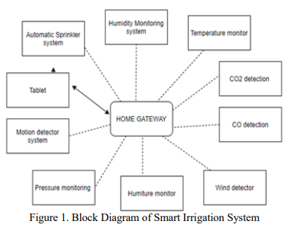

**5. IMPLEMENTATION**

* To connect the home gateway network, a registration server is required.
* Connect network to smart phone and we can do physical configuration like turn on or turn off.
* Home gateway provides the internet access, wireless connectivity and acts as local network.
* After setting up the gateway network, next step is to connect all the smart devices to the home gateway network.
* To configure the devices, select wireless adapter from network adapter.
* After registering all devices to the network, we can monitor each activity in our smart phone.

**Home Gateway:**

* To connect to the network, either a home gateway is required or a registration server. After connecting to the tablet to the home gateway, the devices can be turned on and off using the features of the home gateway.
* The home gateway provides internet access and wireless connectivity to the network and acts as a local connection to the IoT smart devices.
* The wireless settings need to be configured by entering the home gateway SSID and selecting WPA2-PSK PSK passphrase and a password for authentication and validation of the wireless network.
* To configure and register the smart IoT devices with a home gateway, the following steps should be done. Select the device, and in the I/O config, select wireless adapter from the network adapter dropdown list.
* Select Config to verify that the device has established a wireless connection to the correct SSID. Then, Select Config/Settings and select the home gateway as the IoT server registration device.

**Automatic Sprinkler System:**

* The automatic sprinkler system consists of a lawn sprinkler, water level monitor, water drain, and a light indicator.
* The user can set the parameters for the water level monitor according to requirements. If the level of the water goes up to the minimum required level, it turns the lawn sprinkler off and turns the water drain on automatically.
* Similarly, it turns the Sprinkler on if the level of water is less than the required level.
* The light indication is provided when the irrigation system is on to alert the users.

**Humidity Monitoring System:**

* In this system, a humidity sensor is used. Humidity sensors are used to sense the humidity in the environment.
* This sensor is registered to the home gateway. After the network configurations, the values of the humidity sensor can be viewed on the Tablet.
* Further, to make it more convenient, a humidifier is used. A humidifier is a device used for increasing the level of moisture in the environment. The users can set the conditions accordingly.

**Other Monitoring Devices:**

* The germination time of the seeds and plants may shorten due to frequent changes in the atmospheric pressure.
* This System has an Atmospheric Pressure level indicator for proper monitoring of atmospheric pressure levels and taking adequate measures that may help to increase the growth of plants and cause more massive and rapid root growth. Another aspect is the Humiture monitor, which helps in monitoring both temperature and humidity levels.
* The temperature monitor senses the temperature levels in the atmosphere. The Wind detector detects wind in the environment.
* The carbon monoxide and carbon dioxide detect the carbon monoxide and carbon dioxide levels, respectively.

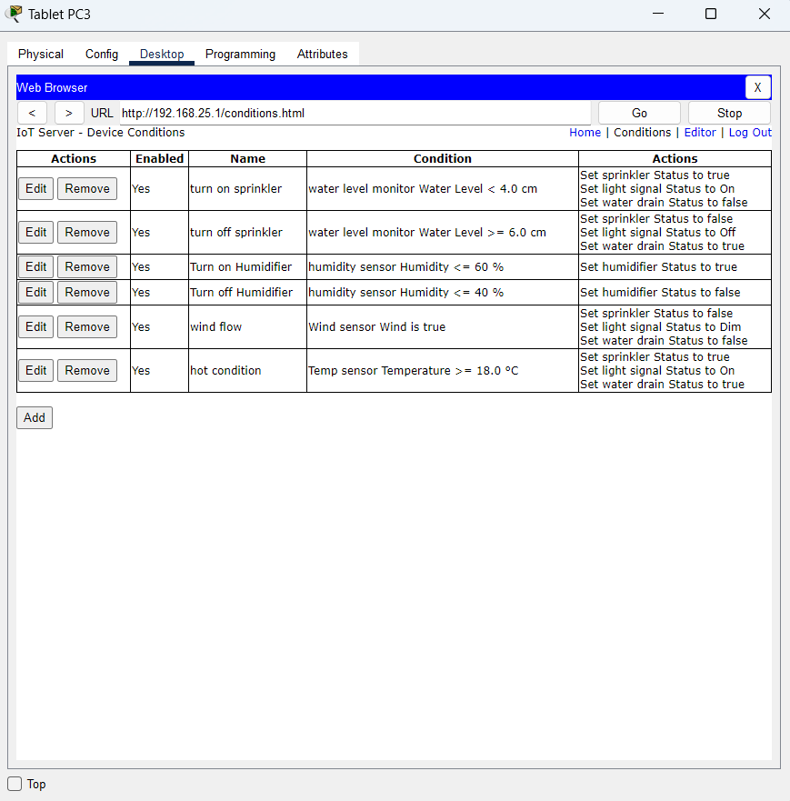

***Figure 2. Shows the conditions set for the automatic water sprinkler system and humidity monitoring system.***

1. **EXPERIMENT RESULTS & OUTPUT**

* After registration of the devices with the home gateway, to control the IoT devices remotely using a tablet.
* The devices can be manually operated as well as the values can be viewed and monitored in real-time.
* The numerical values of the sensors that are displayed on the Tablet shows the status of the IoT devices registered with the home gateway.
* We can change our requirements for Irrigation process like water level control and humidity control etc.
* All the messages in the IoT devices can be viewed on tablet.

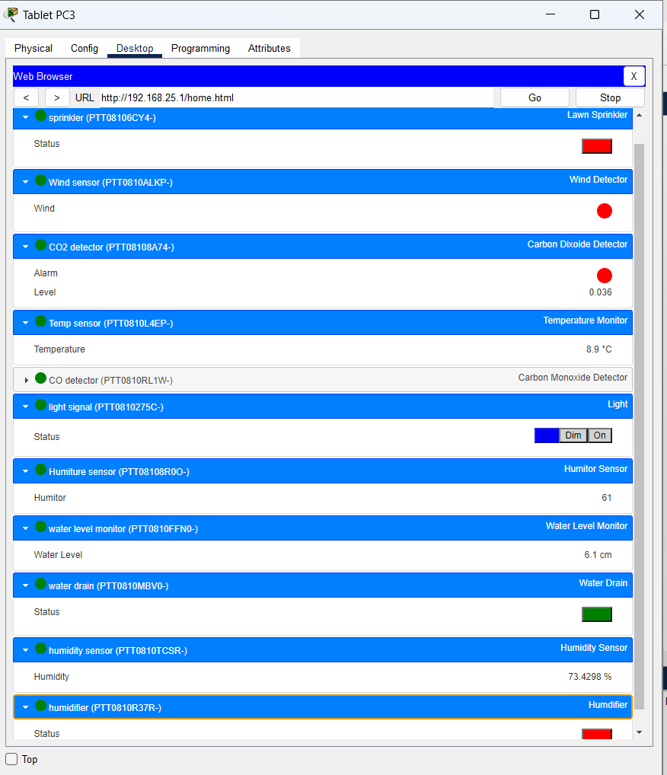

***Figure 3. Shows the status and numerical values of each IoT sensor.***

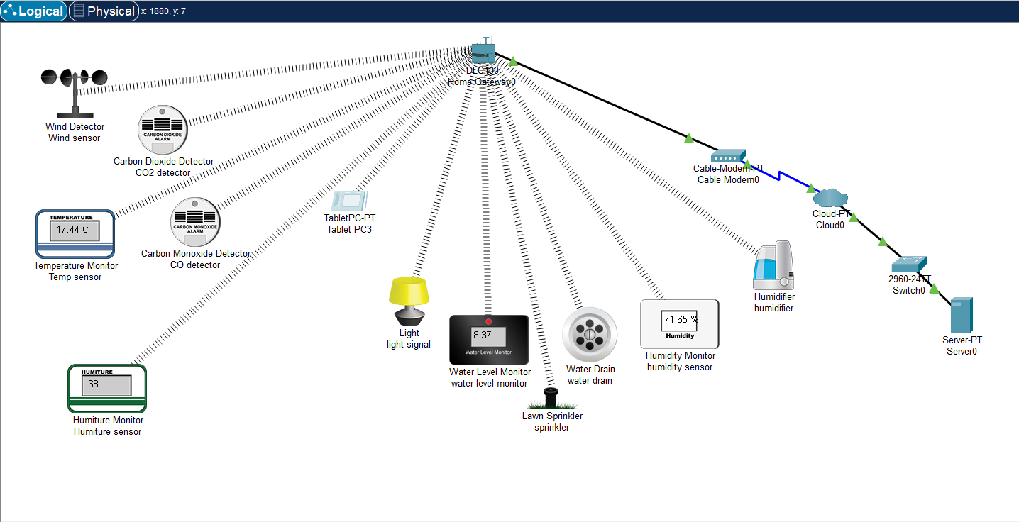

***Figure 4. Shows the lawn sprinkler status when they are OFF condition.***

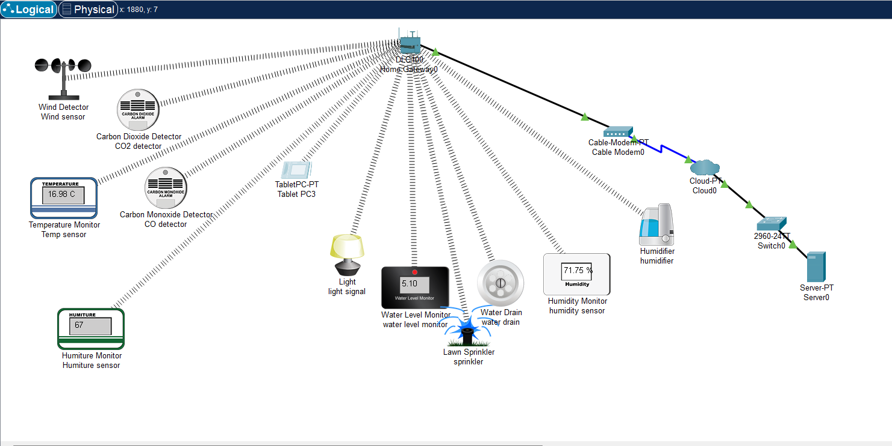

***Figure 4. Shows the lawn sprinkler status when they are ON condition.***

* The above scenario works on the conditions and requirements given by user.

1. **CONCLUSION AND FUTURE SCOPE**

* A smart irrigation system is implementing using the Cisco packet tracer. A home gateway to register the devices and control them using a tablet.
* All the IoT devices connected to the home gateway can be monitored manually as well as remotely by the user.
* Using this smart irrigation system, we can reduce the use of water.
* The network is secured because IoT devices are interconnected to the each other.
* In the field of IoT, ensuring security should be a priority. Since the IoT devices are interconnected to each other, the network should be secured.
* In this system, an authentication gateway is designed that requires password to check authenticity of the home user for security purpose.

1. **REFERENCES**

* Website:<https://www.ijcseonline.org/pdf_paper_view.php?paper_id=5299&3-IJCSE-08461.pdf>
* Book: INTERNET OF THINGS SIMULATION USING CISCO PACKET TRACER by David THERA.